Full Paper Title in Title Case (Font: Times New Roman 18 bold)

First Author Smith¹, Second Author Smith² and Third Author. Smith³
1 Full address of first author, including affiliation and email
2 Full address of second author, including affiliation and email
3 Full address of third author, including affiliation and email
(use Times new Roman 10 typeface for author’s Affiliation)

ABSTRACT
This file provides a template for writing papers for the conference. The conference proceedings will be published in an electronic format. The full paper file shall be written in compliance with these instructions. The author is asked to submit the paper in MS-Word. Both files shall be saved with the full first author name as name of the file. An abstract not exceeding 300 words, in English, should appear on the top of the first page, after the title of the paper in chapter titled "Abstract" (without chapter number), after the names of the authors and the contact information of the corresponding author.

Keywords: Maximum 6 keywords separated by comma.

1. INTRODUCTION
It is expected that authors will submit carefully written and proofread material. Spelling and grammatical errors, as well as language usage problems, will reduce the chances the paper to be published in special issue. The number of pages are not limited.

Papers should clearly describe the background of the subject, the authors work, including the methods used, results and concluding discussion on the importance of the work. Papers are to be prepared in English and SI units must be used. Technical terms should be explained unless they may be considered to be known to the conference community.

Papers should clearly describe the background of the subject, the authors work, including the methods used, and concluding discussion on the importance of the work. Technical terms should be explained. Acronyms should be written out at their first appearance.

2. SUBMITTING THE Paper
The full paper has to be submitted electronically via the website of the conference (https://www.mypadnow.com/icitfes2020) and please check the website for the last date of submission. Kindly check the updates from the conference website for more information.

3. paper format
The uniform outlook will help the reader to follow the proceedings. This can be obtained most easily if authors use this template file to construct their papers. Please note the following details: this template is an A4 format. All text paragraphs should be single spaced, with first line intended by 10 mm (0.4 inch). Double spacing should only be used before and after headings and subheadings as shown in this example. Position and style of headings and subheadings should follow this example. No spaces should be placed between paragraphs.

3.1. Fonts
Papers should use 12-point Times New roman font. The styles available are bold, italic and underlined.

3.2. Tables and Figures
Figure captions and table headings should be sufficient to explain the figure or table without needing to refer to the text. Figures and tables not cited in the text should not be presented. Styles Heading Table and Caption Figure are available in this template for tables and figures. The following is the example for Table 1.
Table 1 Title of Example Table
Standard Error | 20 Story |  |  |  | 30 Story
 | Uniform | ELF | SRSS | 3 Modes | Uniform | ELF | SRSS | 3 Modes
Displacement | 29.53 | 44.58 | 41.05 | 23.81 | 27.4 | 43.6 | 40.87 | 20.65
Drift | 60.4 | 60.92 | 60.47 | 38.24 | 60.91 | 63.83 | 63.53 | 26.19

Tables and figures should be placed close after their first reference in the text. All figures and tables should be numbered. Table headings should be above the tables. Figure captions should be centred below the figures.

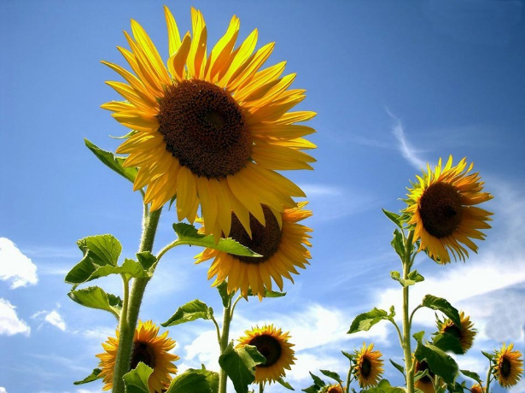
Figure 1: 30 Floor Building’s Drift Ratios Percent

ACKNOWLEDGEMENTS
It is encouraged to write the acknowledgement to funding agencies of the Indian Government where appropriate in addition to the institute that you belongs.

REFERENCES
- Abu, A.B. and Zakaria, B. Title of the manuscript in journal. Name of the Journal Volume (Year), Page no.
- Klemmer, R.S., Thomsen, M., Phelps-Goodman, E., Lee, R. and Landay, J.A. Title of the article in proceedings. In Title of the Proceedings, Publisher (Year), Page no.
- Schwartz, M. Title of the Book. (Publisher Name, Publisher City, Year), Page no.
- Choo, S.M. Title of a PhD thesis. Institution, Ph.D. Thesis, Year.
- S. Zafar. (2015, 20 December). Bioenergy Developments in Malaysia. Available: http://www.bioenergyconsult.com/tag/biomass-resources-in-malaysia/

