**A STUDY ON PERCEPTION OF INVESTORS TOWARDS MUTUAL FUND**

**MS. SANDHYA KUMARI.B**

Assistant Professor,

Faculty of Commerce,

Shakuntaladevi International Institute Of Management Sciences.

Email: [bsandhyakumari.123@gmail.com](mailto:mariamyself@rediffmail.com)

Phone no:9741561892

**MS. PALLAVI P HARAPANHALLI**

Assistant Professor,

Faculty of Commerce,

Shakuntaladevi International Institute Of Management Sciences.

Email: [pallaviph@gmail.com](mailto:sureshsucha@gmail.com)

Phone no:7353638287

**ABSTRACT**

"LIFE IS FULL OF UNCERTAINITIES, PERSON HAVING LOT OF MONEY TODAY MAY LAND UP WITH NO MONEY TOMMORROW .Investment in some kind of financial instrument will help us. When we decide about investing the very next question before us is where to invest? Investing in mutual fund would be an answer to the question.

Why mutual fund? That is because most of the people are not interested in the day-to-day management of the funds but are interested in the final outcome of the investment. Hence, they pool their money together, hire an investment manager who manages funds for them and expect to earn a return on them.

Mutual fund is an financial instrument, the concept of mutual fund started in India in the year 1963.It is an investment vehicle that allows several investors to pool their resources in order to purchase stock, bonds and other securities. Quite simply, a [mutual fund](http://www.idfcmf.com/) is a mediator that brings together a group of people and invests their money in stocks, bonds and other securities.

The main objective of presenting this paper is to show the impact of investing in mutual fund. Since every coin has two faces so has the mutual fund so this study also focuses to make people aware of pros and cons of investing in mutual fund

SEBI has been undertaking various initiatives in order to derive the benefits of mutual fund to the investors .No doubt it has made tremendous growth from its inception. But certain complexities and uncertainties continue to fetter its progress.

Through this paper an attempt is done to create awareness among people the importance of investing and also to persuade people to invest in mutual fund. Necessary information related to this paper will be collected through primary and secondary data

**keywords**

mutual fund

financial instrument

**INTRODUCTION**

**“Live as if you were to die tomorrow. Invest as if you were to live forever.”** human wants has no limit and no end, but an individual has an end. The income seems to be very less when a person tries to fulfill all his wants. When an individual tries to keep his life style according to the changing trend he may land up without any savings .Thus investment is regarded as **"a process of saving a bit out of what we earn"**. That is why, warren Buffett meant “do not save what is left after spending, but spend what is left after saving".

Investment in some kind of financial instrument is always better.A real or virtual document representing a legal agreement involving some sort of monetary value is called financial instrument.There are different types of financial instrument like equities, mutual funds, bonds, deposits etc.investing in mutual fund would an smart optionAn investment vehicle that is made up of a pool of funds collected from many investors for the purpose of investing in securities such as stocks, bonds, money market instruments and similar assets. Mutual funds are operated by money managers, who invest the fund's capital and attempt to produce capital gains and income for the fund's investors. These collective funds are then invested by an expert fund manager appointed by a mutual fund company called Asset Management Company.

**chart showing working of mutual fund**

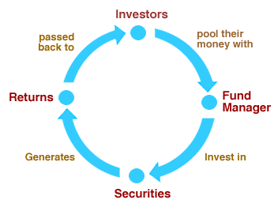

**HISTORY**

The mutual fund industry in India began in 1963 with the formation of the Unit Trust of India (UTI) as an initiative of the Government of India and the Reserve Bank of India. Much later, in 1987,SBI Mutual Fund became the first non-UTI mutual fund in India. Subsequently, the year 1993 heralded a new era in the mutual fund industry. This was marked by the entry of private companies in the sector. After the Securities and Exchange Board of India Act was passed in 1992, the SEBI Mutual Fund Regulations came into being in 1996. Since then, the Mutual fund companies have continued to grow exponentially with foreign institutions setting shop in India, through joint ventures and acquisitions. As the industry expanded, a non-profit organization, the Association of Mutual Funds in India (AMFI), was established on 1995. Its objective is to promote healthy and ethical marketing practices in the Indian mutual fund Industry. SEBI formulates policies and regulates the mutual funds to protect the interest of the investors. SEBI notified regulations for the mutual funds in 1993.

Thereafter, mutual funds sponsored by private sector entities were allowed to enter the capital market. The regulations were fully revised in 1996 and have been amended thereafter from time to time. SEBI has also issued guidelines to the mutual funds from time to time to protect the interests of investors. All mutual funds whether promoted by public sector or private sector entities including those promoted by foreign entities are governed by the same set of Regulations. There is no distinction in regulatory requirements for these mutual funds and all are subject to monitoring and inspections by SEBI.

**ADVANTAGES OF MUTUAL FUND**

**1) Diversification**

**2)** They are managed by a team of professionals.

**3**) You can begin buying units or shares with a relatively small amount of money.

**4)** Units or shares in a mutual fund can be bought and sold any business day.

**DISADVANTAGES OF MUTUAL FUND**

**1)** The return on your investment depends heavily on that manager’s skill and judgment.

**2**) Fees for fund management services and various administrative and sales costs can reduce the return on your investment.

**REVIEW OF LITERATURE**

**Singh and Jha (2009)**

Conducted a study on awareness & acceptability of mutual funds and found that consumers basically prefer mutual fund due to return potential, liquidity and safety and they were not totally aware about the systematic investment plan. The invertors’ will also consider various factors before investing in mutual fund.

**Lenard (2003)**

Empirically investigated investor’s attitudes toward mutual funds. The results indicate that the decision to switch funds within a fund family is affected by investor’s attitude towards risk,current asset allocation, investment losses, investment mix, capital base of the fund age, initial fund performance, investment mix, and fund and portfolio diversification. The study reported that these factors are crucial to be considered before switching funds regardless of whether they invest in non-employer plans or in both employer and non-employer plans.

**Bollen (2006)**

 Studied the dynamics of investor fund flows in a sample of socially screened equity mutual funds and compared the relation between annual funds flows & lagged performance in SR funds to the same relation in a matched sample of conventional funds. The result revealed that the extra-financial SR attribute serves to dampen the rate at which SR investors trade mutual funds. The study noted that the differences between SR funds and their conventional counterparts are robust over time and persist as funds age. The study found that the preferences of SR investors may be represented by conditional multi-attribute utility function (especially when SR funds deliver positive returns). The study remarked that mutual fund companies can expect SR investors to be more loyal than investors in ordinary funds.

**Walia and Kiran (2009**)

Studied investor’s risk and return perception towards mutual funds. The study examined investor's perception towards risk involved in mutual funds, return from mutual funds in comparison to other financial avenues, transparency and disclosure practices. The study investigated problems of investors encountered with due to unprofessional services of mutual funds. The study found that majority of individual investors doesn’t consider mutual funds as highly risky investment. In fact on a ranking scale it is considered to be on higher side when compared with other financial avenues. The study also reported that significant relationship of interdependence exists between income level of investors and their perception for investment returns from mutual funds investment.

**Saini (2011)**

Analyzed investor’s behavior, investors’ opinion and perception relating to various issues like type of mutual fund scheme, its objective, role of financial advisors / brokers, sources of information, deficiencies in the provision of services, investors’ opinion relating to factors that attract them to invest in mutual and challenges before the Indian mutual fund industry etc. The study found that investors seek for liquidity, simplicity in offer documents, online trading, regular updates through SMS and stringent follow up of provisions laid by AMFI.

**Singh (2012)**

Conducted an empirical study of Indian investors and observed that most of the respondents do not have much awareness about the various function of mutual funds and they are bit confused regarding investment in mutual funds. The study found that some demographic factors like gender, income and level of education have their significant impact over the attitude towards mutual funds. On the contrary age and occupation have not been found influencing the investor’s attitude. The study noticed that return potential and liquidity have been perceived to be most lucrative benefits of investment in mutual funds and the same are followed by flexibility, transparency and affordability.

**STATEMENT OF THE PROBLEM**

As we know that, the trend of mutual fund industry in India is coming down, due to many factors investor are scared to opt mutual fund because of major entry and exit load, lack of returns, there is a lot of misconception on mutual fund, therefore investors are confused whether go for mutual fund or not, there is lot of confusion among the investor either directly to invest in stock market or to take help of mutual fund.

Therefore the study is required to understand the investor attitude and perception towards mutual fund and to understand the investors’ expectations and perception toward mutual fund in towards scenario.

**OBJECTIVE OF THE STUDY**

1) The objective of the research is to study and analyze the awareness level of investors of mutual funds.

2) To get insight knowledge about mutual funds.

3) To know the mutual funds performance levels in the present market.

4) To measure the satisfaction level of investors regarding mutual funds

**OPERATIONAL DEFINITIONS**

**I. Open-Ended**- This scheme allows investors to buy or sell units at any point in time. This does not have a fixed maturity date.

1. **Debt/ Income** - In a debt/income scheme, a major part of the investable fund are channelized towards debentures, government securities, and other debt instruments. Although capital appreciation is low (compared to the equity mutual funds), this is a relatively low risk-low return investment avenue which is ideal for investors seeing a steady income.

2. **Money Market/ Liquid** - This is ideal for investors looking to utilize their surplus funds in short term instruments while awaiting better options. These schemes invest in short-term debt instruments and seek to provide reasonable returns for the investors.

3. **Equity/ Growth**- Equities are a popular mutual fund category amongst retail investors. Although it could be a high-risk investment in the short term, investors can expect capital appreciation in the long run. If you are at your prime earning stage and looking for long-term benefits, growth schemes could be an ideal investment.

a) **Index Scheme** - Index schemes is a widely popular concept in the west. These follow a passive investment strategy where your investments replicate the movements of benchmark indices like Nifty, Sensex, etc.

b) **Sectoral Scheme** - Sectoral funds are invested in a specific sector like infrastructure, IT, pharmaceuticals, etc. or segments of the capital market like large caps, mid caps, etc. This scheme provides a relatively high risk-high return opportunity within the equity space.  
  
c) **Tax Saving** - As the name suggests, this scheme offers tax benefits to its investors. The funds are invested in equities thereby offering long-term growth opportunities. Tax saving mutual funds (called Equity Linked Savings Schemes) has a 3-year lock-in period.

4. **Balanced** - This scheme allows investors to enjoy growth and income at regular intervals. Funds are invested in both equities and fixed income securities; the proportion is pre-determined and disclosed in the scheme related offer document. These are ideal for the cautiously aggressive investors.  
  
II. **Closed-Ended** - In India, this type of scheme has a stipulated maturity period and investors can invest only during the initial launch period known as the NFO (New Fund Offer) period.

1. **Capital Protection** - The primary objective of this scheme is to safeguard the principal amount while trying to deliver reasonable returns. These invest in high-quality fixed income securities with marginal exposure to equities and mature along with the maturity period of the scheme.  
  
2. **Fixed Maturity Plans**  - FMPs, as the name suggests, are mutual fund schemes with a defined maturity period. These schemes normally comprise of debt instruments which mature in line with the maturity of the scheme, thereby earning through the interest component (also called coupons) of the securities in the portfolio. FMPs are normally passively managed, i.e. there is no active trading of debt instruments in the portfolio.

III. **Interval**- Operating as a combination of open and closed ended schemes, it allows investors to trade units at pre-defined intervals.

**Research Methodology**

The data collection methods include both Primary and Secondary collections methods:-

**PRIMARY METHOD:**

Primary method includes the data collected directly from the investors. An appropriate questioner is served to the investing community for collection of primary data. And also data collected from discussion with some investors officially.

**SECONDARY METHOD:**

The secondary data collections from the magazines, Economics time, internet and various books relating to the investment.

**ANALYSIS AND INTERPRETATION**

**TABLE NO 1**

**GENDER OF RESPONDENTS**

|  |  |  |
| --- | --- | --- |
| **GENDER** | **NO OF RESPONDENTS** | **PERCENTAGE** |
| Male | 40 | 80 |
| Female | 10 | 20 |
| Total | 50 | 100 |

The above Chart reveals about the gender of the respondents. It is clear from the above chart that 80% of the respondents are male and 20% of the respondents are female. This shows that Majority of the investors are male but still there are some smart female investors who are good in tackling the market trend.

**TABLE NO 2**

**AGE OF RESPONDENTS**

|  |  |  |  |
| --- | --- | --- | --- |
| **AGE** | **NO.OF RESPONDENTS** | | **PERCENTAGE** |
| Below 18 years | 0 | | 0 |
| 18-35 years | 33 | | 66 |
| 35-50 years | 10 | | 20 |
| 50 years above | 7 | | 14 |
| Total | | 50 | 100 |

The above chart indicates the age of the respondents. The age of the respondents is classified into below 18 years and 50 years & above in which 66% of the respondents are between 18-35 years and 20% are between 35-50 years and remaining 14% of the respondents are 50 years & above. This gives us an understanding that in the survey the younger lot up to the age of 35 was approached more because of their capabilities to experiment the challenges. And the respondents above this age up to the age of 50 were also approached due to their experience in investing and also the 50 and above category where its more about retirements and savings.

**TABLE NO 3**

**QUALIFICATION OF RESPODENTS**

|  |  |  |
| --- | --- | --- |
| **Qualification** | **NO OF RESPONDENTS** | **PERCENTAGE** |
| Graduate | 29 | 58 |
| Post graduate | 14 | 28 |
| Profession | 07 | 14 |
| Total | 50 | 100 |

The above chart shows the qualification of the respondents and it is clear that 58% of the respondents are graduates, 28% are post-graduates, and the remaining 14% are professional. This indicates that large amount of investors are qualified as to the grade of graduation and engaged in the investment in mutual fund.

**TABLE NO 4**

**OCCUPATION OF THE RESPONDENTS**

|  |  |  |
| --- | --- | --- |
| **OCCUPATION** | **NO OF RESPONDENTS** | **PERCENTAGE** |
| Employed | 17 | 34 |
| Self- employed | 14 | 28 |
| Homemaker | 02 | 04 |
| Student | 08 | 16 |
| Professional | 06 | 12 |
| Retired | 03 | 06 |
| Total | 50 | 100 |

The above table shows the occupation of the respondents. It is clear from the above table that 34% of the respondents are employed, 28% of the respondents are self- employed,4% of the respondents are homemaker,16% of the respondents are student,12% of the respondents are professionals and 6% of the respondents are retired. This gives the understanding that most of the respondents are employed.

**TABLE NO 5**

**AWARENESS OF MUTUALFUND**

|  |  |  |
| --- | --- | --- |
| **RESPONDENTS** | **NO OF RESPONDENTS** | **PERCENTAGE** |
| Aware | 08 | 16 |
| Unaware | 42 | 84 |
| Total | 50 | 100 |

In the above pie chart, we can observe that nearly 84% of investors are aware of mutual funds and only 16% people are not aware of it. This shows that most of the investors know about mutual funds in one or the other way.

**TABLE NO 6**

**PREFERENCE FOR SCHEME OF INVESTMENT IN MUTUAL FUNDS**

|  |  |  |
| --- | --- | --- |
| **SCHEME** | **NO OF RESPONDENTS** | **PERCENTAGE** |
| Balanced fund | 23 | 46% |
| Equity diversified | 20 | 40% |
| Debt fund | 7 | 14% |
| Others | 0 | 0% |
| Total | 50 | 100% |

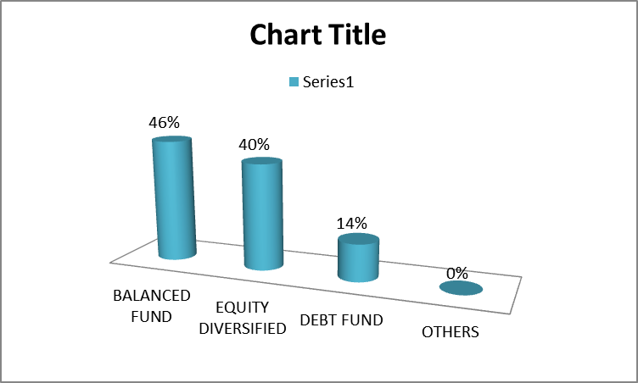

From the above table it is clear that 46% of respondents wants to invest in balanced fund scheme, 40% respondents wants to invest in equity diversified scheme, 14% respondents wants to invest in debt fund scheme & 0% in other scheme. Thus it can be analyzed that highest percentage of the respondents prefer investing in balanced fund scheme.

**TABLE NO 7**

**RATING OF RISK ASSOCIATED WITH MUTUAL FUND**

|  |  |  |
| --- | --- | --- |
| **Rating** | **NO OF RESPONDENTS** | **PERCENTAGE** |
| Low | 10 | 20 |
| Moderate | 32 | 64 |
| High | 08 | 16 |
| Total | 50 | 100 |

The above table shows the risk associated with mutual fund. It is clear from the above table that 20% of the respondents feel the risk is low and 64% respondents feel the risk is moderate and 16% of the respondents feel its highly risk. From this we can draw a conclusion that majority of respondents feel that the risk involved in investment in mutual fund is moderate .

**TABLE NO 8**

**FACTORS CONSIDERED BEFORE INVESTING IN MUTUAL FUND**

|  |  |  |
| --- | --- | --- |
| **Factors** | **NO OF RESPONDENTS** | **PERCENTAGE** |
| Enquiring about the fund manager | 15 | 30 |
| Finding the past performance | 27 | 54 |
| Identify your own objective | 08 | 16 |
| Total | 50 | 100 |

The above table shows factors that are considered by the investors before investing in mutual fund. It is clear that 30% of the respondents enquire about the fund manager and 54% of the respondents study the past experience and 16% identify their objective before investing. so the majority respondents study the past performance before investing which can be considered as good beginning.

**TABLE NO 9**

**TYPE OF RISK ASSOCIATED**

|  |  |  |
| --- | --- | --- |
| **Risk** | **NO OF RESPONDENTS** | **PERCENTAGE** |
| Systematic | 08 | 16 |
| Unsystematic | 42 | 84 |
| Total | 50 | 100 |

The above Chart reveals about the type risk which affects the mutual Fund. Out of the total respondents 16% of the respondents are in the opinion that systematic risk affects the mutual fund and rest 84% are in the opinion that mutual fund gets affected due to unsystematic risk.

**TABLE NO 10**

**TERM OF IVESTMENT IN MUTUAL FUND**

|  |  |  |
| --- | --- | --- |
| TERM | NUMBER OF RESPONDENTS | PERCENTAGE OF RESPONDENTS |
| 1 TO 3 YEARS | 27 | 54% |
| 4 TO 6 YEARS | 20 | 40% |
| 7 TO 10 YEARS | 3 | 6% |
| MORE THAN 10 YEARS | 0 | 0% |
| TOTAL | 50 | 100% |

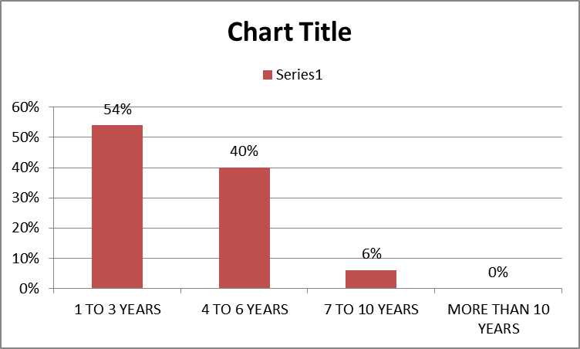

From the above table it is clear that 54% of the respondents’ term of investment in mutual fund is between 1 to 3 years, 40% of the respondents’ term of investment is 4 to 6 years, 6% of the respondents’ is 7 to 10 years and none of the investor wants to hold the investment more than 10 years. This shows that investors doesn’t want to hold the investment for more years.

**TABLE NO 11**

**PERCENTAGE OF INVESTMENT MADE BY THE RESPONDENTS**

|  |  |  |
| --- | --- | --- |
| **INVESTMENT (%)** | **NO OF RESPONDENTS** | **PERCENTAGE** |
| Upto 10% | 19 | 28 |
| Upto 25% | 29 | 58 |
| Upto 50% | 02 | 04 |
| Above 50% | 00 | 00 |
| Total | 50 | 100 |

The above chart points out the percentage of investment made by the respondents in the mutual fund .It is clear that out of 50 respondents, 29 respondents invest up to 10%, 19 respondents invest up to 8%,2 respondents invest up to 4% and no respondents are willing to invest more than 50% in the mutual fund which indicates that the safety measure is taken by the investors.

**TABLE NO 12**

**SOURCES OF INFORMATION DEPENDENT BY THE INVESTORS**

|  |  |  |
| --- | --- | --- |
| SOURCES | NUMBER OF RESPONDENTS | PERCENTAGE OF RESPONDENTS |
| TELEVISION | 6 | 12% |
| BROKER | 10 | 20% |
| INTERNET | 26 | 52% |
| OTHER SOURCES | 8 | 16% |
| TOTAL | 50 | 100% |

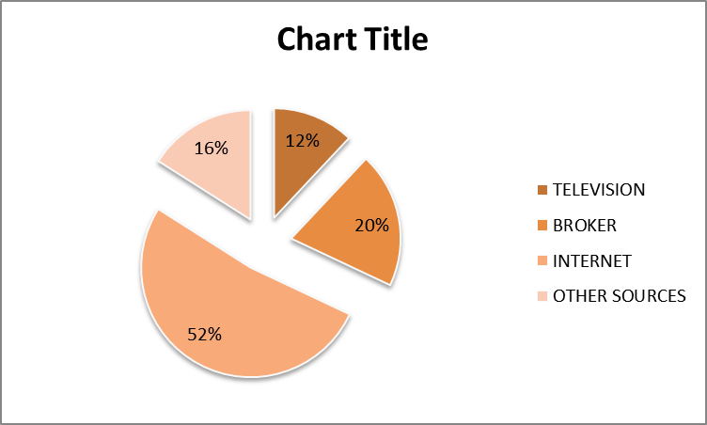

From the above table it is clear that 12% of respondents know the information about mutual funds from television, 20% from broker, 52% from internet and 16% from other sources. Thus it can be analyzed that highest percentages i.e. 52% of respondents know the information about mutual funds from internet.

**TABLE NO 13**

**RESPONDENTS OPINION ABOUT OTHER TYPE OF INVESTMENT**

|  |  |  |
| --- | --- | --- |
| TYPE | NUMBER OF RESPONDENTS | PERCENTAGE OF RESPONDENTS |
| MUTUAL FUNDS | 3 | 6% |
| STOCK MARKETS | 0 | 0% |
| BANK DEPOSITS | 47 | 94% |
| OTHERS | 0 | 0% |
| TOTAL | 50 | 100% |

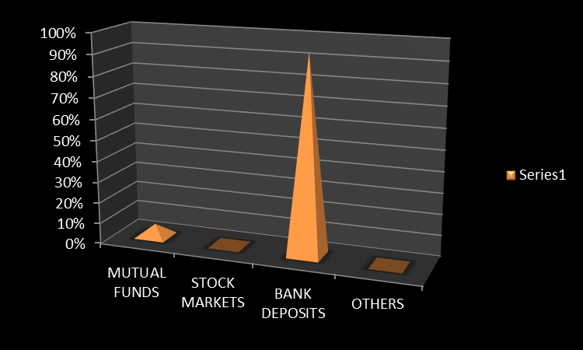

From the above table it is clear that 6% of the respondents want to invest in mutual funds, 0% in stock markets, 94% in bank deposits and 0% in others. Thus it can be analyzed that the highest percentage i.e. 94% respondents wants to keep their savings in bank deposits.

**FINDINGS:**

After an extensive study conducted on the awareness of investors regarding online and offline trading in equity market following were the findings of the study.

* The study states that majority of investors are male. Still it has been proved that female investors are smarter and cautious in investments.
* Majority of respondents are between the age group of 18-35 years. This gives us an understanding that in the survey the younger lots up to the age of 35 were approached more because of their capabilities to experiment and also since this age is when a more aggressive investment can happen.
* The study reveals that most of the respondents are educated.
* The study reveals that majority of the respondents are aware of the mutual fund only few are unaware.
* Most of the investors prefer balanced fund type of mutual fund.
* Majority of the investors also feel that the risk associated with mutual fund is moderate, which indicate it is manageable.
* The study also reveals that investors consider past performance of mutual fund. This proves that investors take cautious steps before investing.
* Majority of the investors invest up to 25% of their savings, this shows that investors are smart.
* The study also reveals that some investors would prefer investing in mutual fund when compared to other source of investment.
* Though the mutual fund performance was not up to the expectations, investors still feel that there would be a better return in the years to come.

**CONCLUSION**

Almost all have accepted the fact that life is full of uncertainties, this realization has made people to invest a part of their earning .But Managing the investments successfully requires complete understanding of the peculiarities of the mutual fund. This study has made an attempt to understand the perception of investors towards mutual fund. It is been observed that many of the people have a fear of investing in mutual fund that is because of unaware of mutual fund benefits and also of bitter past experience. To conclude people are aware of mutual fund investment. As far as the benefits Provided by mutual funds are concerned, return potential and liquidity have been perceived to be most attractive by the invertors’ followed by flexibility, transparency and affordability. But few have a fear of losing their hard earned money. So mutual fund companies should take some steps to spread more knowledge and benefits of investing in mutual fund.

Apart from the above, in India there is a lot of scope for the growth of mutual fund.

**REFERENCE**

Preeti Singh, Investment Management ,Security Analysis and Portfolio Management, Himalaya Publishing House, page no-2

S.Kevin, Security Analysis and Portfolio Management, Published by Asoke K. Ghosh, PHI learning Private limited, Page no.10-11.

Agapova, Anna, 2011, „The Role of Money Market Mutual Funds in Mutual Fund Families‟ Journal of Applied Finance, Vol. 21, Issue. 1, pp. 87-102.2.

A. Vennila, R. Nandhagopal(2012) “Investors’ Preference towards Mutual Funds in Coimbatore City European Journal of Social Sciences ISSN 1450-2267 Vol.29 No.1 (2012), pp. 115-1254.

Binod Kumar Singh (2011) “A Study on Investors’ Attitude towards Mutual Funds as an Investment Option “journal of Asian business strategy”, vol. 1(2): 8-155.

Dr.Nishi Sharma (2009) “Indian Investors Perception towards mutual funds” Business Management DynamicsVol.2, No.2, Aug 2012, pp.01-098.

Gil-Bazo, Javier; Ruiz & Verd, Pablo, 2009, „The Relation between Price and Performance in the Mutual Fund Industry

Singh, Chander, 2004, „Performance of mutual funds in India – empirical evidence.

**WEBSITES**

http://en.wikipedia.org/wiki/Mutual_fund

http://money.msn.com/mutual-fund/

www.mutualfundindia.com

http://www.amfiindia.com/research-information/mf-history